# Winston Dashboard and Security Instructions

# Summary

The purpose of this document is to outline user interface changes to Winston and introduce new Winston security rules by agency. Winston will now include a customizable dashboard, roles for each Winston user, and single user sign on. Our goal of this project is to provide Winston users a more streamlined agency experience to securely manage/service their book of business with FWCI.

# Old Winston View

### 1. Quotes

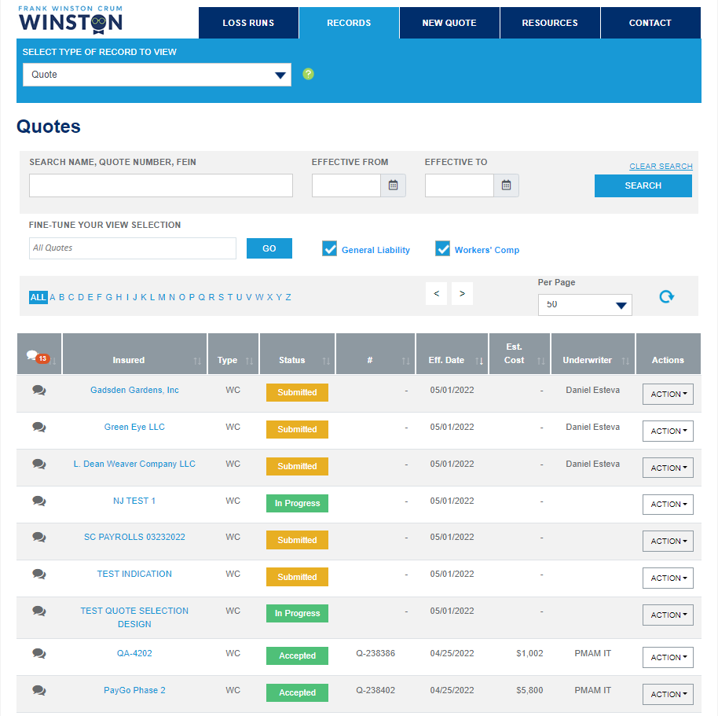

### 2. Policies

### 3. Payments Past Due

### 4. Renewals Not Yet Paid

### 5. Agent Endorsement Request (Saved Endorsements)

# Agency Security Structure

### Hierarchy

The hierarchy structure is the basis of the entire project. The structure is built upon the idea that agency branches at the top of hierarchy have visibility into below branches. An agency in a below branch does not have visibility up or across the same branch level.

For example: In the below Demo Structure, the FC131201 branch (top branch) can see all quotes, policies, and endorsements in the below branches. The FC131204 branch cannot see quotes, policies, or endorsements in FC131201, FC131203, FC131205 or FC131202. The FC131204 branch can see quotes, policies, and endorsements in the FC131203.

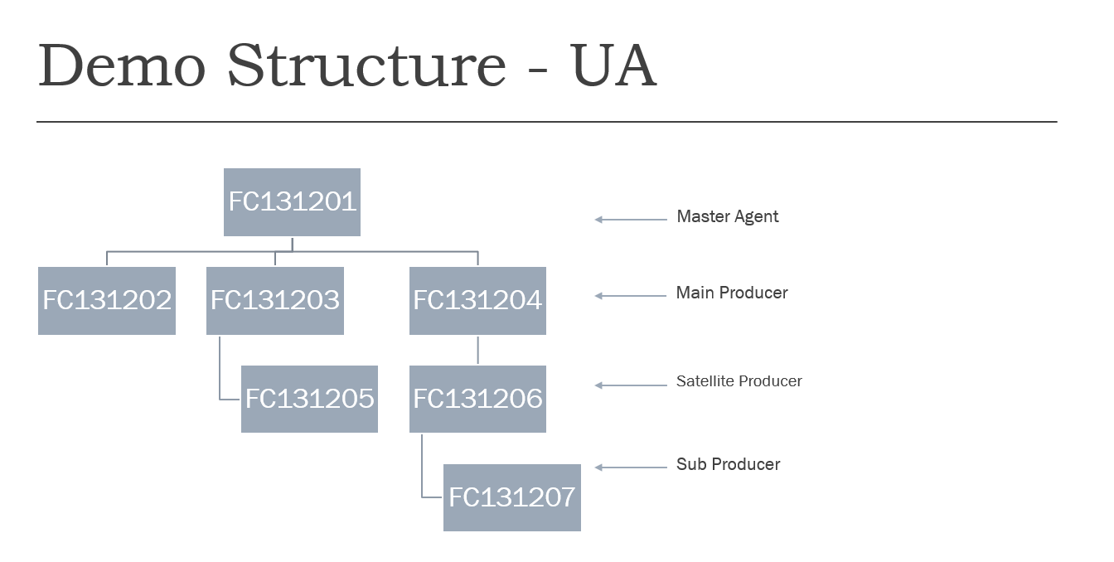

### New User Set Up

#### Workflow

After the user is set up by Admin Role or Master Agent, User will receive an email with

# New Winston View

### Introduction of Panels

* Upon logging in the first time, the user will be shown the following default panels: Book of Business (If applicable), Quotes, Payments Past Due and Renewals Not Yet Paid.

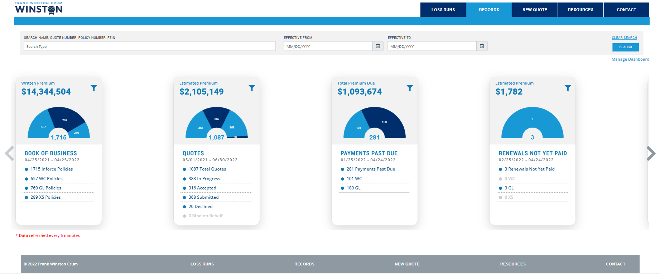

* To view information within a panel, the user must click into the section to view the information. The information will then be displayed at the bottom of the screen.
* Example: Total Inforce Policies is selected

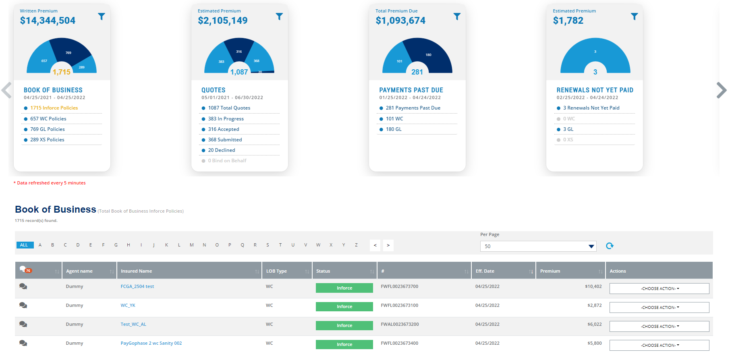

### Available Panels

The following panels will be available for a user to display in their dashboard. Panels available will be dependent on the security permission tied to the user. All panels may be filtered by line of business unless the panel is a specific line of business panel. The user must have the Book of Business permission to view the Book of Business panel. The user must have the View Commissions permission to view the Commission Statements panel.

|  |
| --- |
| Book of Business (Dependent on security permission) |
| Quotes |
| Payments Past Due |
| Renewals Not Yet Paid |
| Renewals Upcoming |
| GL Policies |
| XS Policies |
| WC Policies |
| Cancelled Policies |
| Pending Cancellations |
| Endorsements |
| Commission Statements (Dependent on security permission) |

#### Book of Business

This panel shows all policies written within the past year broken out by line of business.

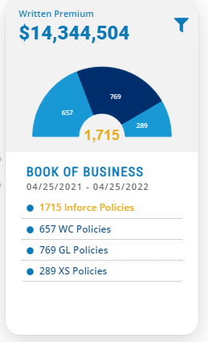

The user can filter this panel by agency by clicking the filter button in the top right of the panel.

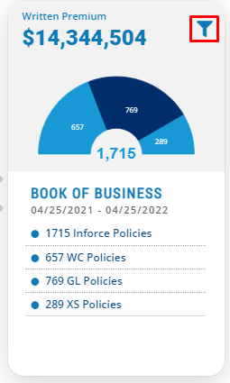

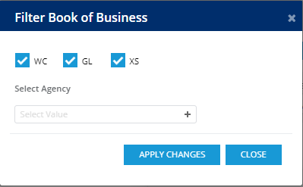

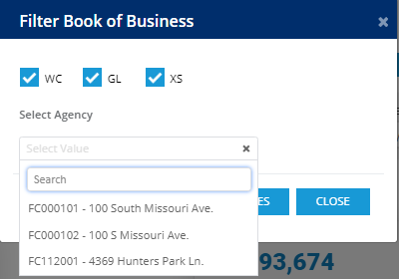

#### Quotes

This panel shows all quotes entered in the past year plus sixty days in the future from todays date. The panel is broken out by status type and can be filtered by agency.

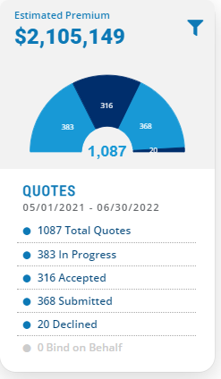

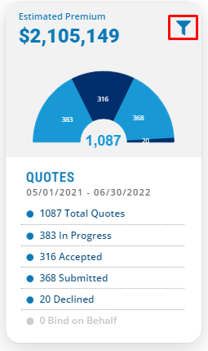

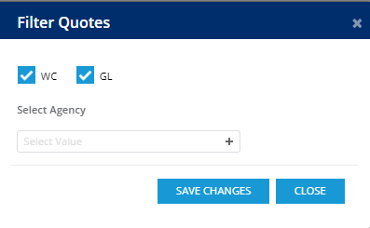

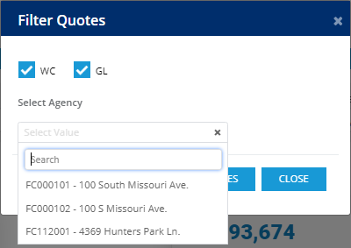

The Bind on Behalf section will appear if the logged in user has the Bind on Behalf Of permission. The Bind on Behalf section will display all Bind on Behalf eligible quotes.

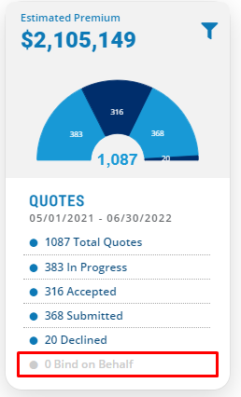

#### Payments Past Due

This panel shows all policies with a past due payment within the last 3 months.

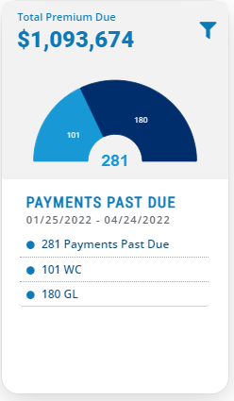

#### Renewals Not Yet Paid

This panel shows renewal policies that have not yet been paid.

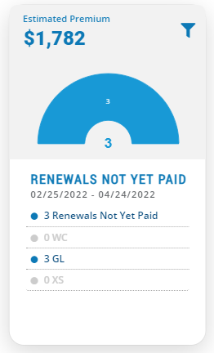

#### Renewals Upcoming

This panel shows renewal policies that have been issued but are not yet effective.

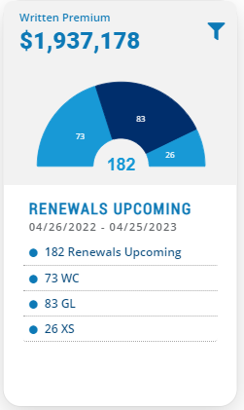

#### GL Policies

This panel shows all inforce general liability policies for the past year and policies that are effective 60 days from today. The panel also shows policies that have expired and have been audited in this timeframe.

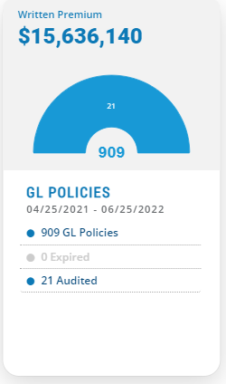

#### XS Policies

This panel shows all inforce excess liability policies for the past year and policies that are effective 60 days from today. The panel also shows policies that have expired in this timeframe.

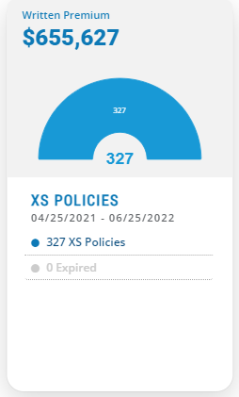

#### WC Policies

This panel shows all inforce workers compensation policies for the past year and policies that are effective 60 days from today. The panel also shows policies that have expired and have been audited in this timeframe.

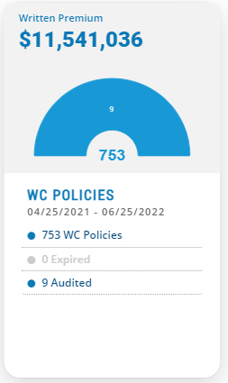

#### Cancelled Policies

This panel shows policies that have been cancelled in the past 2 months.

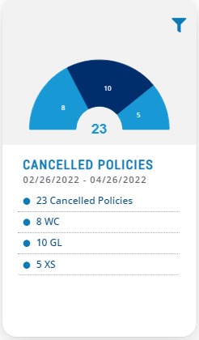

#### Pending Cancellations

This panel shows all policies that are pending cancellation.

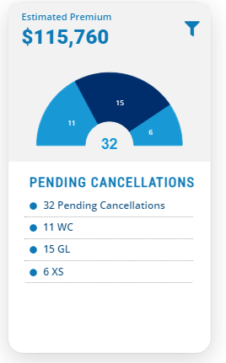

#### Endorsements

This panel shows endorsements submitted broken out by endorsement status. The In Progress section replaces the Agent Endorsement Request section in the old Winston landing page.

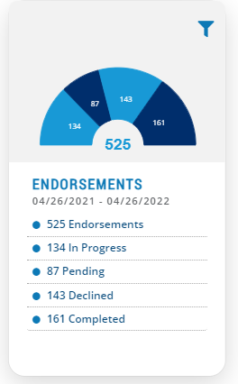

#### Commission Statements

This panel shows all agency commission statements uploaded in the past year. Commission statements are uploaded monthly.

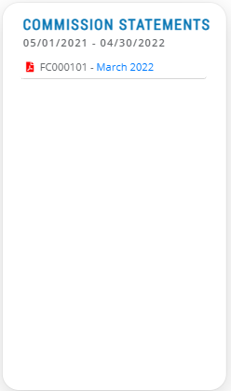

### Customizing the Dashboard

Each individual user has the ability customize their own dashboard and save preferred dashboards for access at a later date. This means certain panel layouts can be displayed and saved. Certain panels can be hidden, and the order of the panels can be re-arranged.

#### Workflow

* Click Manage Dashboard in the upper right of the screen.

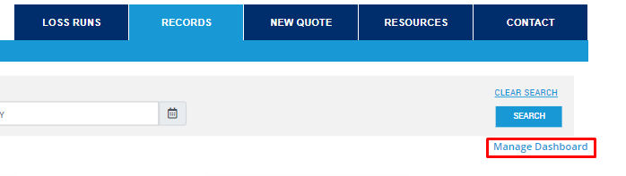

* The Manage Dashboards section appears.

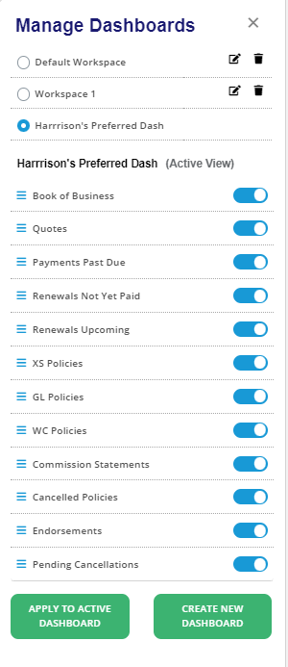

##### The user can hide available panels or rearrange panels and apply to current dashboard

Example: Turning on/off panels

Book of Business is On



Book of Business is Off



Example: Rearranging Panels

User would like to display Quotes first and then Book of Business. Click the three lines next to Quotes and drag above Book of Business.

**Before:**

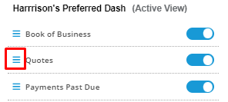

**After:**

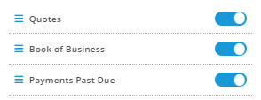

* Once all changes have been made to dashboard, the user clicks Apply to Active Dashboard.

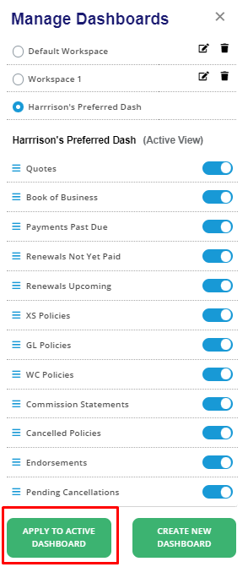

##### Saving Dashboards

* To save dashboards for access at a later date, click Create New Dashboard.

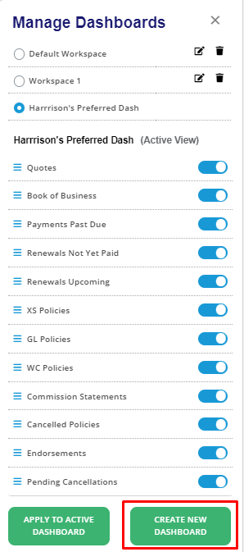

* Winston will ask for the dashboard name and panels needed to be displayed. The panels can be toggled on and off. The new dashboard can be used as the current display or can be saved for later by clicking the Use as current checkbox.

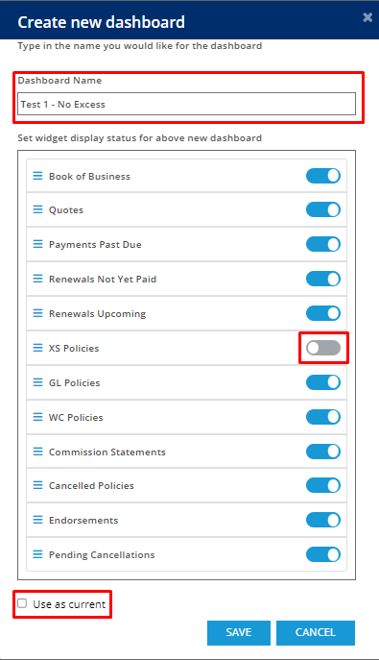

* The user clicks Save, and the newly created dashboard is saved to the top of the Manage Dashboards section.

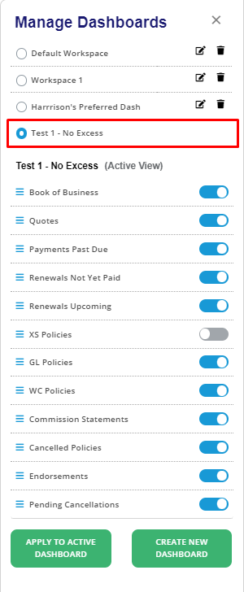

### Loss Runs

Loss runs is a new feature that has been added that allows the agency user to download loss runs for their insureds. This feature will only display if the logged in user has the permission to View Loss Runs.

##### Accessing Loss Runs

* Click the Loss Runs tab to the left of the Records tab

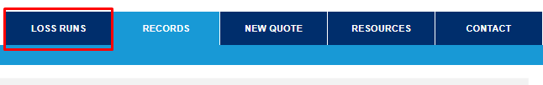

* Loss runs can be searched by Insured Name, Policy Number, Effective Date, Line of Business or Claim Status.

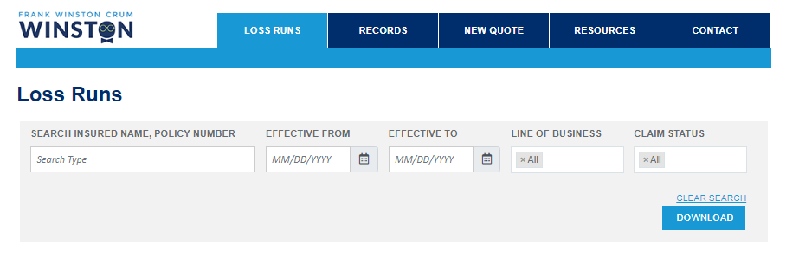

* Once criteria is entered, click download.

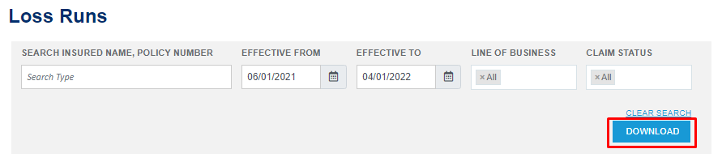

Example of generated loss run:

